Tatton Wildlife Newsletter – Autumn
Fungi
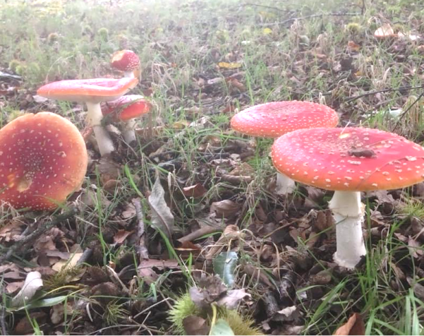
Autumn is the best time to look out for the many and varied species of fungi that can be found in the parkland. One of the most iconic is probably the fly agaric (pictured) Depicted in many fairy tales; it is easily recognised with its red and white speckled cap. It likes to grow under birch trees and where there is one, often several can be found. Another species to look out for is the parasol, which is very large and grows out in the open grassland areas of the park. This is brown and beige in colour and is quite numerous. Some other striking species need to be sought out though as they are small in size, such as certain waxcap varieties which can be found here too and though they also favour the open grassland, they prefer shorter grass. A keen eye will spot the amethyst deceiver, growing under deciduous trees; this beautiful purple species is always striking and a pleasure to see. We also have many types of bracket fungi to look out for with chicken of the woods and beefsteak fungi often found.
All these fungi are the fruiting bodies of the mycelium that thrive underground or in the host tree, these are extremely important to the natural world, breaking things down and removing waste, a valuable process for the ecosystem. This is why fallen branches are left in situ; not only encouraging fungi but providing food and shelter for invertebrates that in turn provides food for birds. We do ask that no fungi, plant or fruit are removed from the parkland, as explained; they provide a valuable service and help to feed the deer and other wildlife allowing them to thrive in the park.
Birds
Our summer migrants are now on the move or have already left us. Autumn is a great time to watch birds as things are changing constantly. Summer visitors are passing through heading south while winter visitors arrive. Early autumn is the best time to see hobbies in the park and two were seen in the first week of September hunting dragonflies over Melchett Mere before their long arduous flight to Africa. Hobbies are becoming less scarce and are known to breed locally. A sure sign of migration on an autumn day is the sound of the meadow pipit overhead as they move down from their montane breeding grounds for the warmer lowlands. Wheatears will pass through and the Mill Pool track is always a good place to spot them. Stonechats will arrive, some wintering with us and short eared owls are always possible at this time of year. Other winter visitors soon to join us are two thrush species from Scandinavia, the redwing and fieldfare. They can be seen feeding on berry bearing bushes and open pasture in the park.
Wildfowl numbers will now increase and males will moult out of their more camouflaged eclipse plumage. This is when the males moult into a much drabber plumage; they lose the ability to fly as they lose their flight feathers and this affords them more protection from predators.
Deer
It is now the time for the deer rut, a spectacular time that is the epitome of autumn. They have spent the summer resting and eating so that they are now in peak physical fitness. Feeding will be limited during the rut. Initially the stags and bucks will endeavour to make themselves look intimidating. They do this by wallowing in muddy scrapes that they have gorged out with their antlers or hooves. The scrapes will fill with water and the deer may urinate in them for added effect! They will thrash their antlers on the ground and adorn them with grass. Towards the end of September the males become more vocal. The red deer stags have a bellowing call that carries a long way, while the fallow bucks have a rasping, snorting call which they often give while ‘parallel walking’. This is where two males will walk alongside each other weighing each other up and intimidating each other.
The last resort is fighting where the antlers lock together and a show of strength ensues. The stronger animal will push the other away to show its dominance. The fighting can be very brief or may last quite some time, depending on how evenly matched they are. Of course the reason for all of this behaviour is to mate and to make sure that the dominant, stronger male’s genes are passed down to the herd and to benefit the species as a whole. The two different species we have at Tatton employ different strategies to do this. The red deer will hold together a group of females called a harem; he will fight off any suitors and defend them for as long as he can. The stronger males will have more females in their harem and can keep them together for longer meaning his genes will proliferate. The fallow deer do things rather differently. They hold a territory called a ‘stand’. This is normally a raised area that they defend, calling the females to them to mate. Injuries and deaths do occur, although they are seldom. Often males can be seen resting after they have taken part in the rut, they will move away from others and start to feed on fallen acorns to regain condition as quickly as possible in preparation for winter.

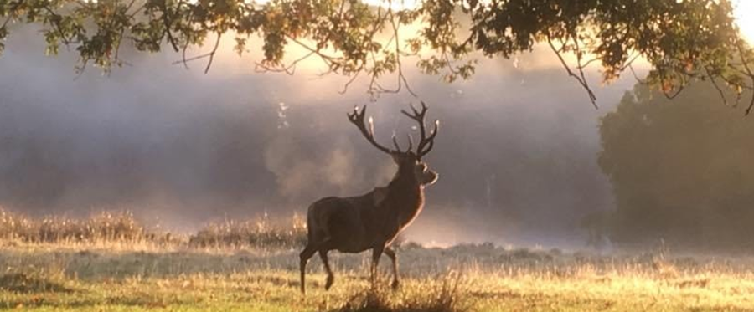
Compiled by Tatton’s Ranger Team

